**Storyboard**

**As a customer I wish to order a drink/snack.**

**As a customer I wish to see what I have ordered**

**As a customer I wish to add to my current order for a drink/snack.**

User selects type of product they wish to view.

User is taken to the page containing the type of products they selected. From here the user can add a product to their order basket. The user is able to add multiple items to their order.

When ready to checkout, user can select order button in header and is redirected to this page where they are asked to enter their name and date of birth to checkout.

From hew the user can also see what they have ordered.

**As a customer I wish to cancel my order for a drink/snack.**

From here the user can press “Remove” to remove any items from their order.

**As the admin I wish to enter details of the drinks/snacks I have for sale.**

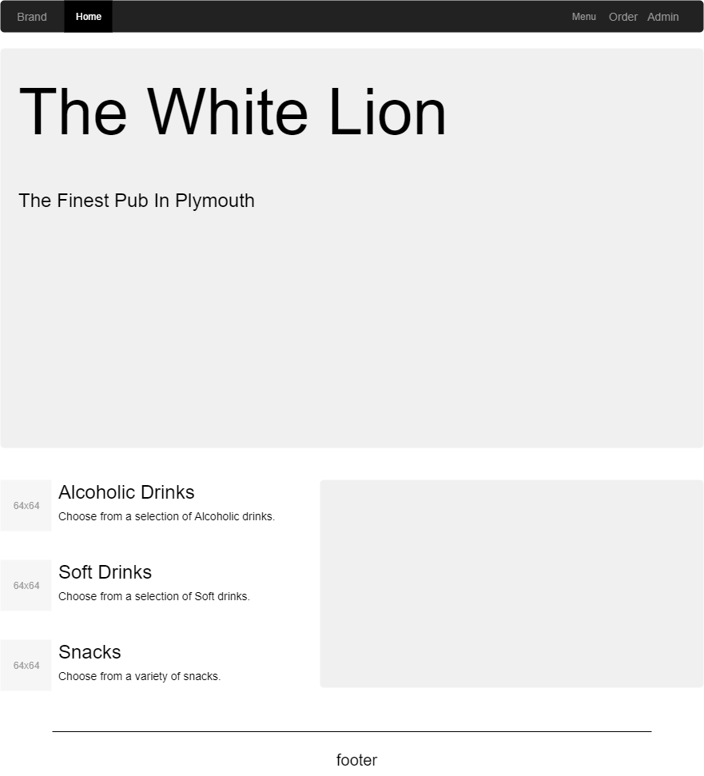User can click on Admin tab in the header to be taken to the admin page.

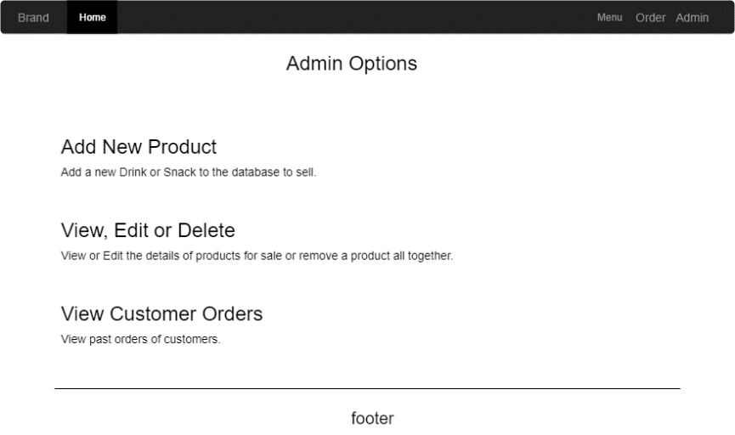If user is not logged in, the user is asked to log into an admin account to access admin options.

When admin has logged in, they have access to admin functions. The admin stays logged in until the “logout” button is pressed in the header.

From here the admin can choose to add a new product for sale. The admin can enter it’s details and then save the product to the database.

**As the admin I wish to read the details of the drinks/snacks I have for sale.**

**As the admin I wish to edit the details of the drinks/snacks I have for sale.**

**As the admin I wish to withdraw a drink/snack from sale**

From the admin page, the user can choose to View, Edit or Delete product details.

Selecting this option will allow the admin to view products by type, then edit the Name, Description and Price of a product. Clicking the “Save” button will save the details entered in the textboxes to the database. Clicking the “Withdraw” button will remove the product from the database and from sale.



**As the admin I wish to view a customer’s order(s).**

The admin will also have the option to view customer orders.

This will allow the admin to enter the ‘customerID’ of a customer and view all past orders of this customer.

**Entity Relationship Diagram**

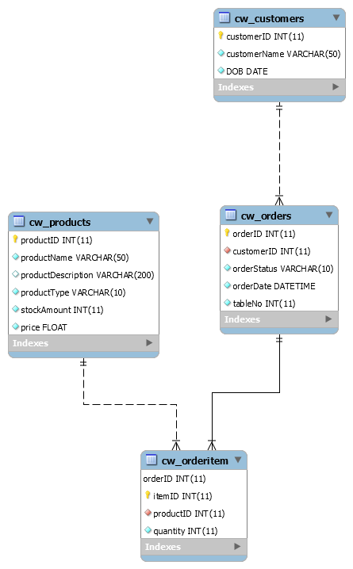

**UML Diagram**

**Peer Review**

Peer Review carried out by: Elliot Lea Date: 21/10/2019

Task conducted: Customer Ordering Drink/Snack

Was the task easy to carry out? (If no or not really, please say why)

Yes.

Did you encounter any errors? (If yes, please explain what)

No.

Did the author have to explain how to use anything? (If yes, what?)

No all was clear enough

Did you gain any inspiration for your own practice? (If so what?)

Yes. Using popups to confirm an order before paying/accepting an order.

What constructive advice would you give the author for presenting their work/code in future?

Everything was presented clearly and understandable.

**URL’s**

Hosted Pages: <http://cent-5-534.uopnet.plymouth.ac.uk/ISAD251/erward/PubApplication/public/index.php>

GitHub: <https://github.com/EvanWard29/ISAD251-Coursework.git>